ESE 3005

Lab #2: UDEV FILE FOR USB MOUNT

Group members:- Shahrukh Padaniya
Rohan Yadav
Swapnil Sevak

Step 1 In order to mount the USB, first power up the BBB and look for if the device is mounted and check the path of the location. What is the proper command? Where is this device mounted?
We need following commands for this task
ssh debian@192.168.7.2
enter password:- temppwd
lsusb
or
fdisk -l
Thus, by this command we can see all the devices connected to beaglebone and its id.

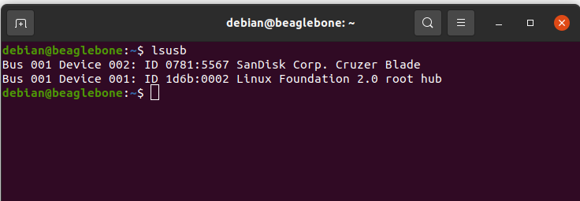

Step 2 In order to mount the particular device to a designated folder you need to know the ID of that device which is unique. What is the proper command? What is your device UUID?

To know the UUID of the connected device we need to insert following commands.
sudo blkid

We have use this command before inserting USB and after inserting USB. It can be seen that device at /dev/sda1 with UUID="468A-E870" and type vfat is present. Thus we can have UUID of the device.

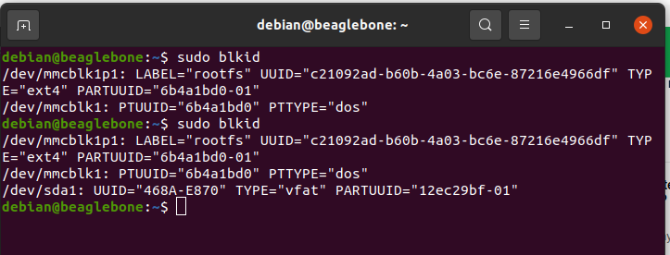

Step 3 Now lets create a folder we wish to designate to the USB and remember the folder should have the permission to read, write and execute thus the mode of the folder would be 777. What is the proper command?

First we will insert into superuser by command sudo -i
sudo -i

We will go into media folder and create folder USB with 777 permissions.
cd /media/
mkdir -m 777 USB

We can check the permission of this folder by following command.
stat -c "%a" USB

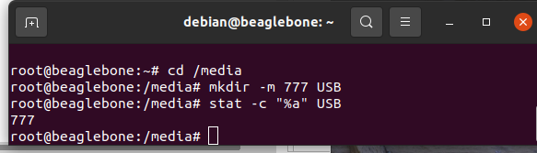

Step 4 Now all the contents of the USB should be available in the folder we have created. To check if the folder is successfully created we use the command “ls”. How?

To mount the folders of USB on this folder named USB, we type following commands
mount UUID="468A-E870" /media/USB

To check if the folder is successfully created, we use these commands
cd /media/USB
ls

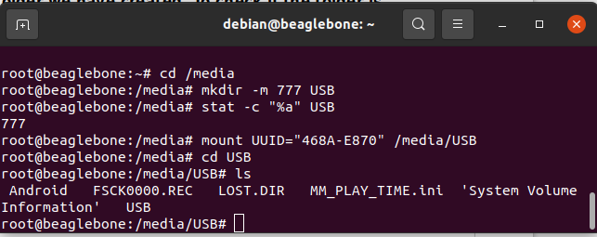

Step 5 Now since the folder is been created we need to state this up in the fstab file which is the file state table which has a list of all the partitions of the memory and devices also having the list on how the devices need to be executed or started upon the boot-up or in the larger file system structure. They are mostly found in the “etc folder”. What is the proper command?

Step 6 The file is now edited and then the path for the variable of USB is mentioned. Add the Universal ID of the USB (How?), the folder it needs to locate to, the format of the USB (usually vfat), for whom it is accessible, and sets the bit for file system check and for dump file.

To perform following task, first we need to edit fstab file by using following command.
nano /etc/fstab

Then, we need to add this line in the file.
UUID=468A-E870 /media/USB vfat defaults,users,umask=0 0 0

After this, we save and exit.

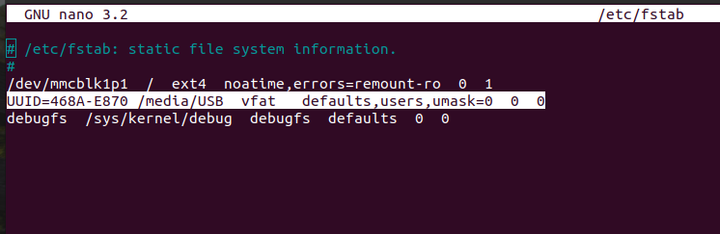

Step 7 Now go to create the rule file so that when the block is encountered; we mount all the devices present in the fstab file (You need a couple of commands here)

For this, we make a rule file with following command.
nano /etc/udev/rules.d/22-USB_mount.rules

Then we add this in the rule file.
SUBSYSTEMS=="usb", RUN+="/bin/mount -a"

After this, save and exit

Step 8 Save this file and reboot the Beagle Bone again and this time do not insert the USB and go that created folder and see that the contents are empty so then when you insert the USB and see that contents of the USB are present in the folder as created.

We can check if this works by using following commands
reboot
or
shutdown -r now

cd /media/USB/
ls
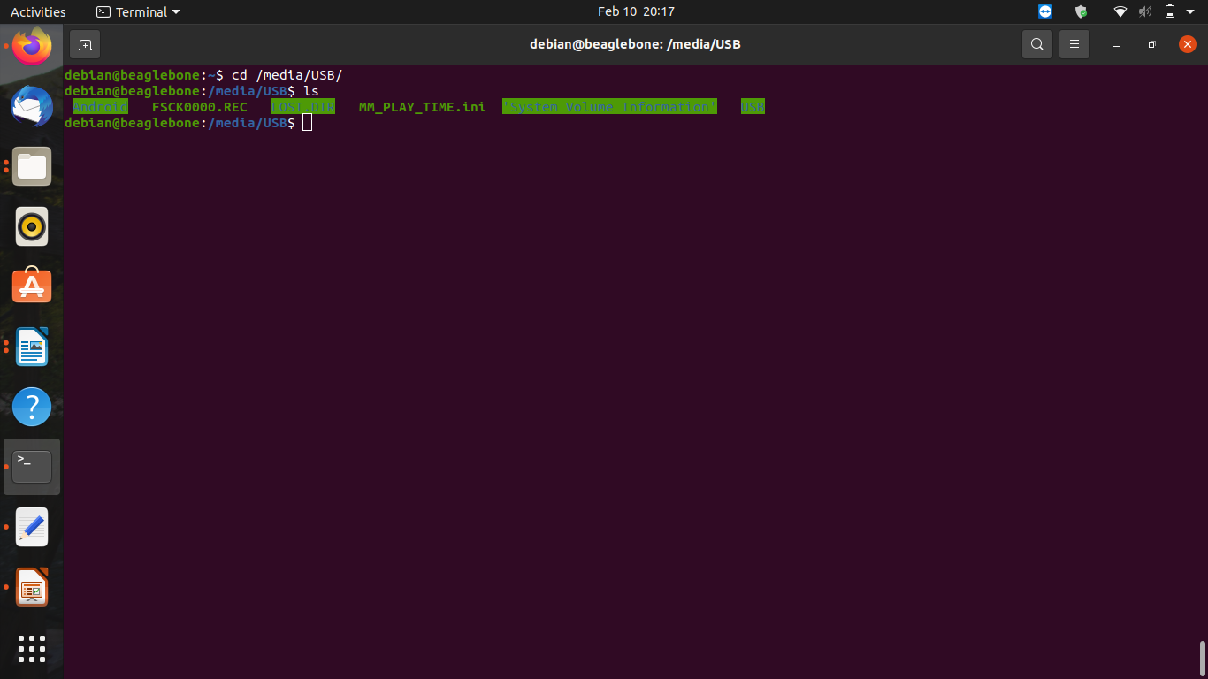

We can see the result above. After the reboot, as we insert the usb drive, we can see files and folders already present and we do not need to mount it manually.

